**Dino Legacy**



**[If you already have a logo, put it here, if you have a studio you can do the same]**

**Raise the strongest Dino and become the king of the colosseum**

Contents

**I. Game Overview 3**

**a. Create your Dino legacy 3**

**b. Genre 3**

**c. Target Audience 3**

**d. Platform and Tolls 3**

e. Why this game? 3

**II. Playability and Mechanics 4**

**a. Main Game View 4**

**b. UI 4**

**c. Evolution Training 5**

**d. Genes Planning 6**

**e. Battle Leagues 6**

f. Auto Battle 6

**g. Taming Dinnosaurs 6**

h. Training Tetromino Rooms 6

**i. Game Controls 7**

**III. Core Gameplay Loop 8**

**IV. Game Elements 8**

**a. Main Characters 9**

**b. Intro Sequence 9**

**c. End Condition 9**

**V. Sound 9**

**a. Music 9**

**b. Sound Effects 9**

**c. Voice Lines 9**

**VI. Mini Art Bible 10**

a. Art Style 10

b. Backgrounds/Levels 14

c. Others 14

# **Game Overview**

## **Create your Dino legacy**

The player represents themselves as the game is planned for a VR experience.

The dinosaurs are not meant to be realistic, as some will evolve into fictional dinosaurs.

The game will take the player as they play some mini games to tame different dinosaurs, train them by giving them the best environment and then take them to the colosseum to build their legacy as the best tamer in the world.

## **Genre**

VR, autobattler, mini games, and management

## **Target Audience**

This game is looking for a 12+ age for its target audience (suitable for change based on PEGI and other laws).

## **Platform and Tolls**

VR - The game is meant to work on stand alone VR devices like the Meta quest 2, however, it does not put aside the option to go for an only linked device route.

C++/unreal - As C++ paired with unreal give the best options to handle 3D and memory usage, something important for VR, those were the tools chosen for the development of the game.

Blender- One of the, if not the best free 3D modeling application with much versitality and support for many add-ons.

## **Why this game?**

The autobattler genre has risen in popularity (2023), however, the combination of genres that we approach this game with is not very common. The inspiration for it is an old game called “Digimon World Championship”. Because of this, the market is very open for its introduction, and being made for VR, even more so.

# **Playability and Mechanics**

## **Main Game View**

Since it is planned for VR, it will take a first person perspective.



## **UI**

The Game will have a “pause” menu that the player will be able to activate by looking at their wrist (would work on both) and pressing a button as if you were pressing some kind of touch pad. For ease of access, there would also be a stationary menu with quick info to the side of the board (would be possible to turn it off).

Pressing a button and holding while looking at the “game board” would pop up info, releasing the button would activate it.

The color scheme for these UI’s would be a blue hue like the following:

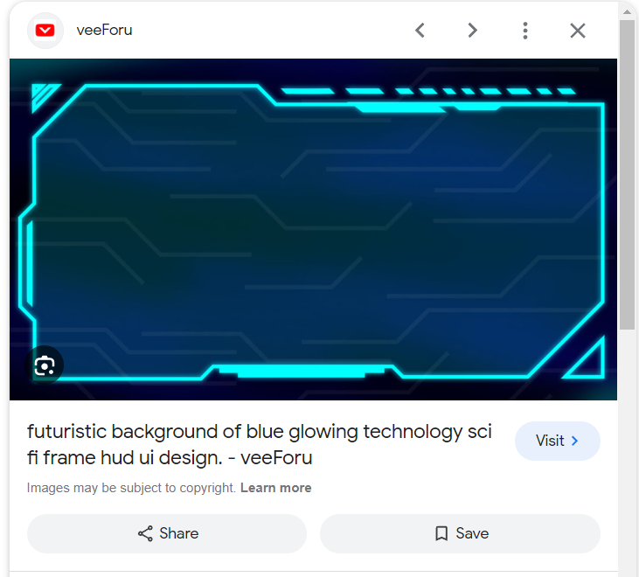

(<https://www.veeforu.com/futuristic-background/futuristic-background-of-blue-glowing-technology-sci-fi-frame-hud-ui-design/>)

## **Evolution Training**

Evolution is a normal occurrence in this game, so take advantage of it, make your dinosaurs train in a certain way so they develop different abilities and evolve in different ways. For example, the same dinosaur when training near a vulcano might increase their fire resistance, but the same dinosaur training inside a blizzard might get the ability to summon “cold” around them.

## **Genes Planning**

The player will have the ability to combine their dinosaurs to create a hybrid that retains some characteristics and unlocks certain abilities down the line. (the player will have a catalogue to be able to check these)

## **Battle Leagues**

Each Dinossaur will have a power rating based on their evolution stage and abilities (they will have a max evolution) and will only be accepted in certain leagues. Each league will have a season and you can switch dinosaurs mid season. The player will get rewards for each combat won (resources) and major rewards for each season won (new training envirorments). Each major reward will be capped, when you get all major rewards of a league, the end reward will swap for more basic resources.

## **Auto Battle**

Depending on League, the player will be able to choose upt to 5 Dinossaurs to fight and will be able to chose different AI behaviours and team dispositions. If you get to a league that let’s you play more than 1 match in a row against the same opponent, the player will be able to switch these in the interval of each battle. After choosing everything, the player will watch their dinosaurs battle and cheer like they were in a colosseum.

## **Taming Dinnosaurs**

Dinosaurs will come in a variety of shapes and sizes. When taming, Stronger dinosaurs will likely not be as friendly, because of that, each dinosaur will have a different mini game needed to tame them and each minigame will also have different difficulties. To even be able to catch some tiers of dinosaurs the player will need specialized tools only unlocked by progressing thought leagues.

It is important to note that at the start the number of dinosaurs a player can have will be low, and thus, whenever catching a dinosaur without space, the player will have the option to kick out PERMANENTELY one of their existing dinosaurs to keep the new one, or keep the current dinosaurs and not adding the new one.

## **Training Tetromino Rooms**

Training rooms take space, and that space is not unlimited, rooms will be Tetromino shaped (or less) and the player will have to mix and match to make a board they are happy with, each training room will be put on the player inventory when not being used.

## **Game Controls**

| Key binds | Function |
| --- | --- |
| Grab | Move/grab dinosaurs/rooms |
| pinch | Interact with dinosaurs |
| A | Confirm |
| B | Cancel/go back |
| X | TBD |
| Y | TBD |
| left menu button | Quick menu open |

# **Core Gameplay Loop**

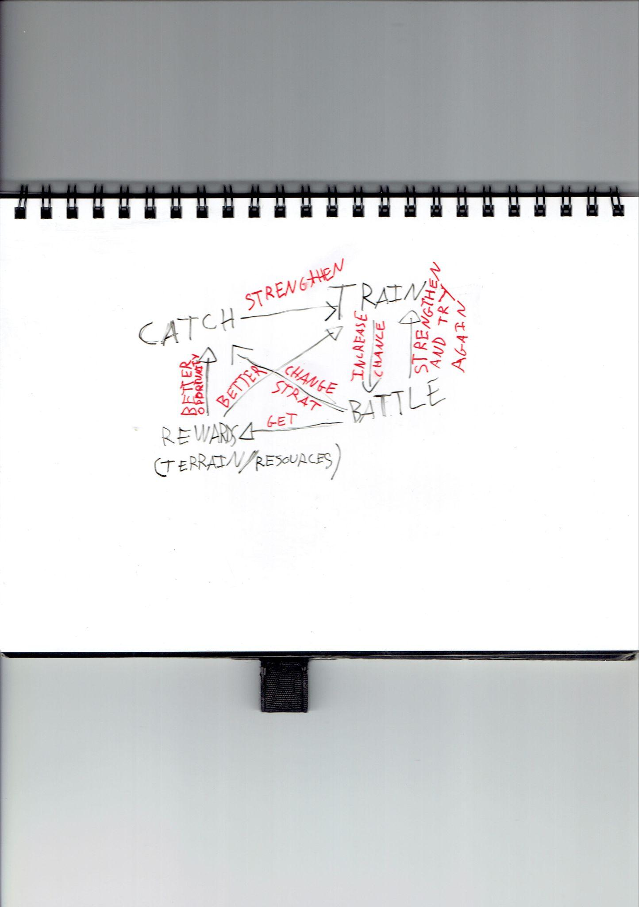

# **Game Elements**

## **Main Characters**

There’s only the player itself as the game has no proper story, all the NPC are blanck characters as well, existing only for filling slots

## **Intro Sequence**

The game would start straight up with the “game board” open and asking if the player wants a tutorial.

## **End Condition**

The player will need to win 1 season of the maximum level league. But the game technically never ends and the player can keep on playing.

# **Sound**

## **Music**

TBD

## **Sound Effects**

TBD

## **Voice Lines**

The game would have voice lines for the tutorial “bot” and for a presenter in the colosseum to narrate the fights.

# 

# **Mini Art Bible**

## **Art Style**

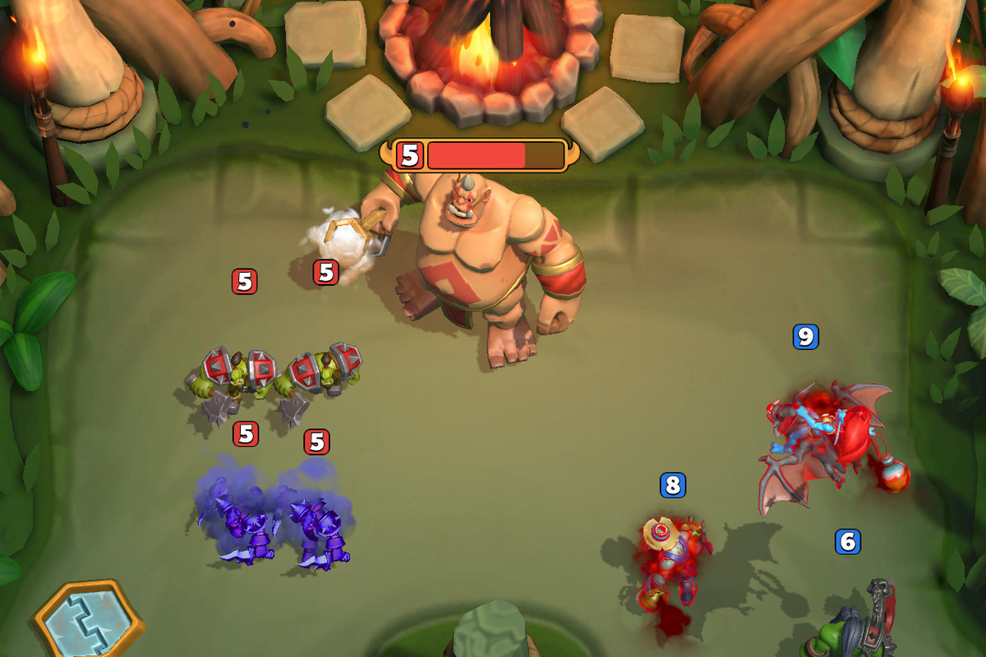

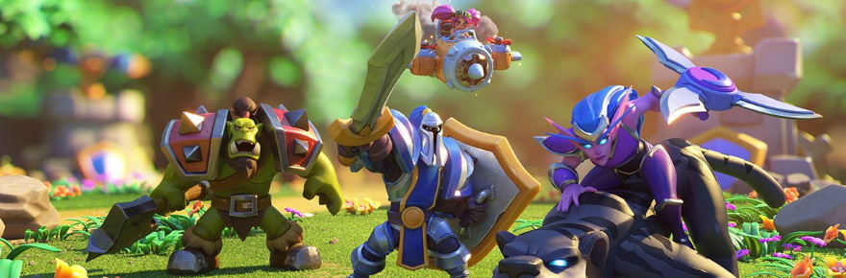

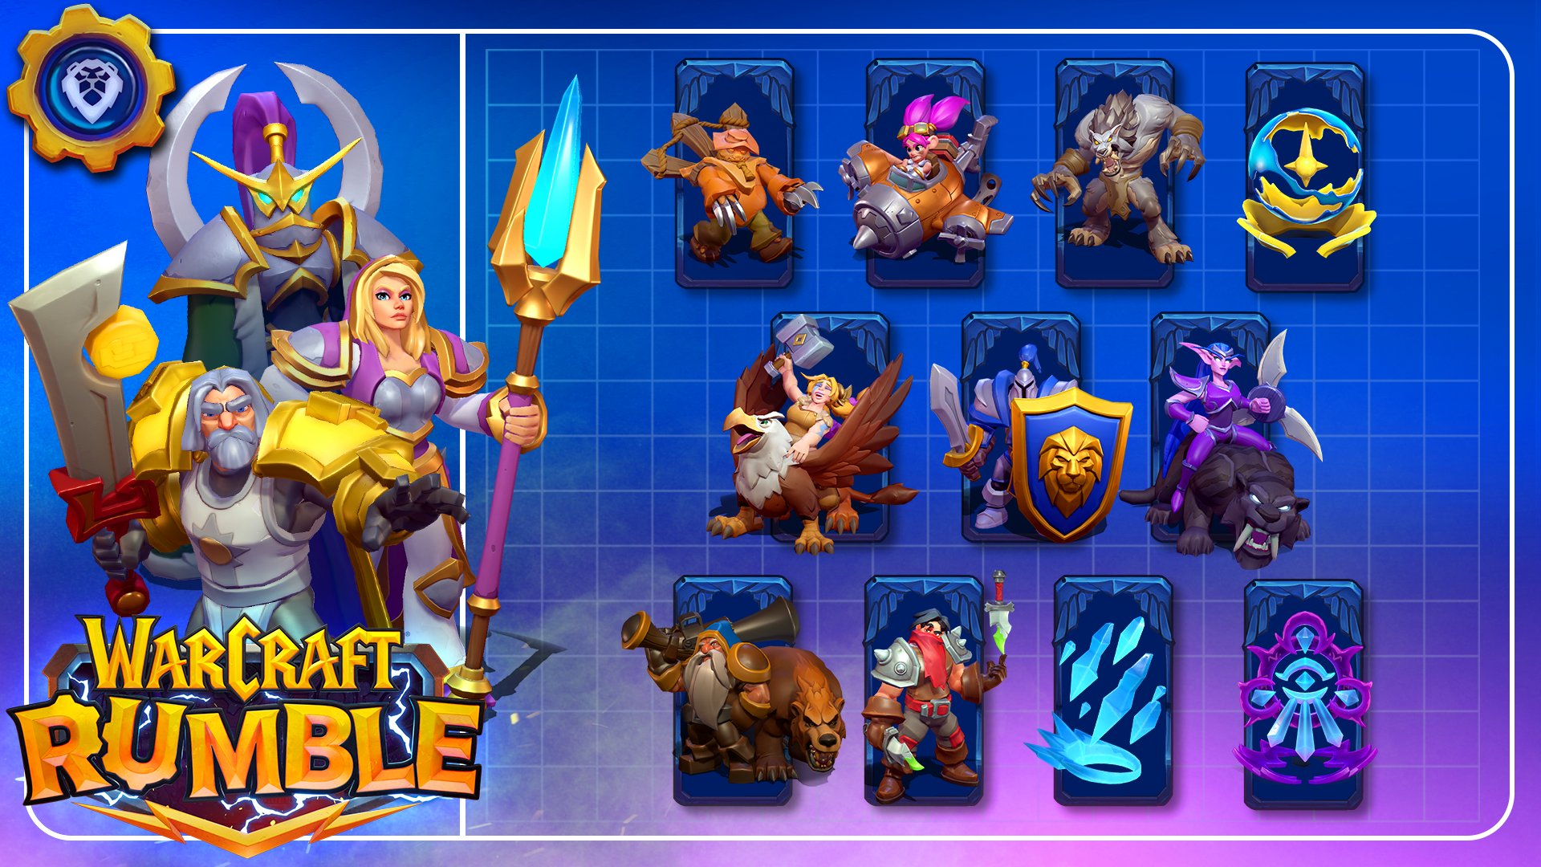All images above are from “warcraft rumble”

The images below are from “mario vs rabbids”

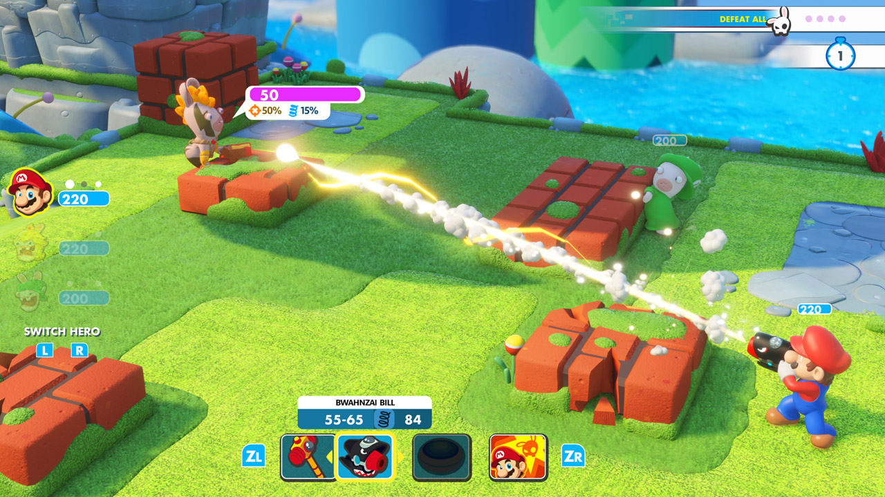

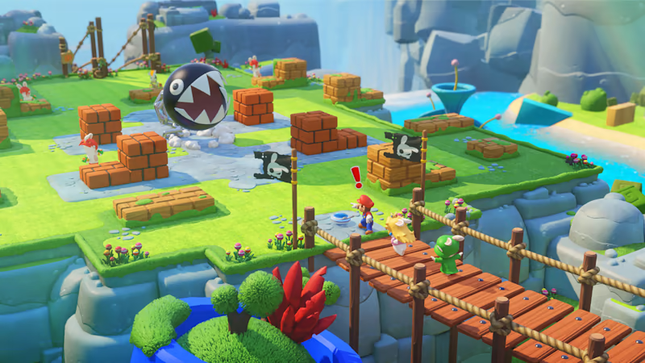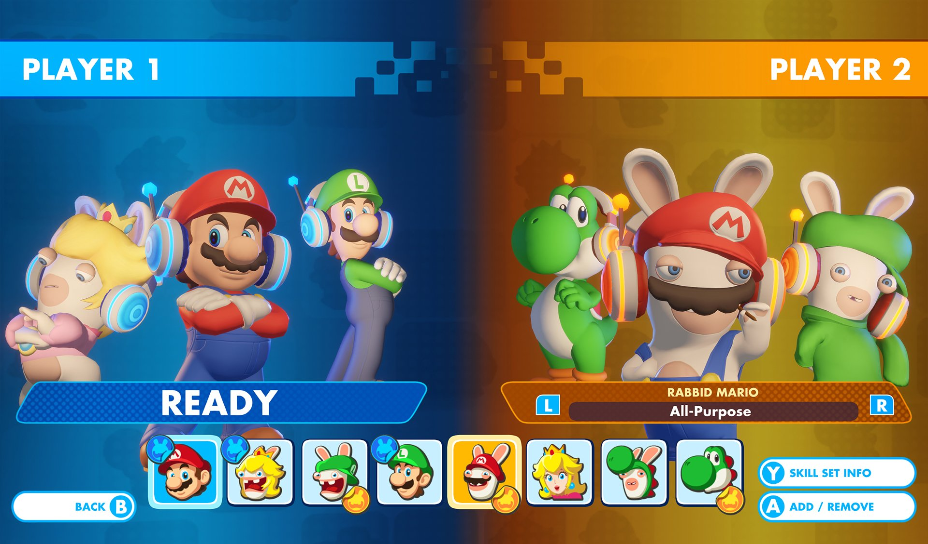

To finalize, the images below are from “figure fantasy”

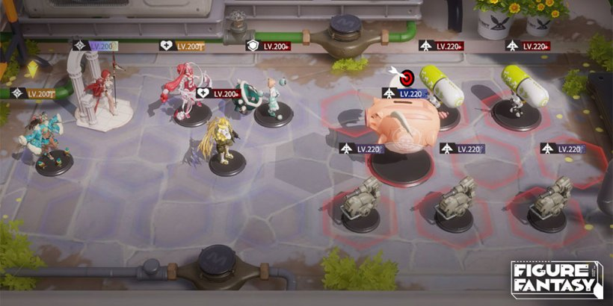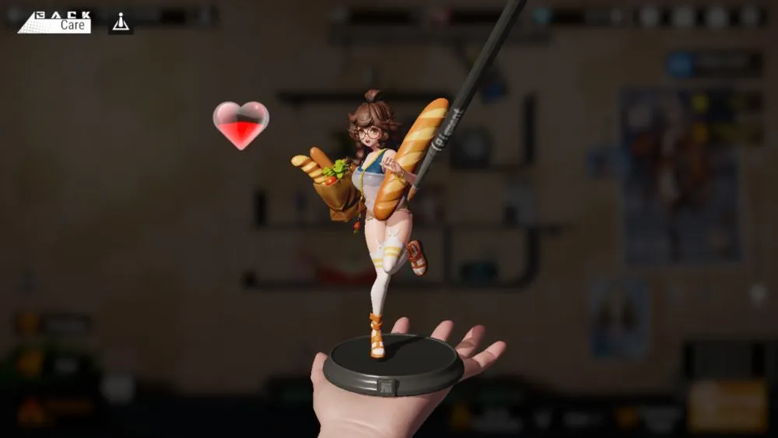

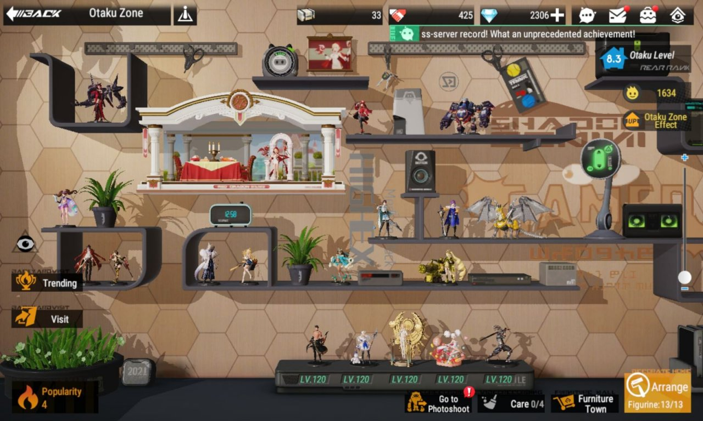

## **Backgrounds/Levels**

TBD

## **Others**

TBD

**The team:**

**[put your name and contact here alongside your position if interested.]**